4.3 Threats to Biodiversity

4.3.1 Studies and findings of CEP II Studies

There is a widespread perception that the Caspian is in a state of ecological decline, and that one aspect of this is a decline in biodiversity. This is of particular concern, due to the status of the Caspian as a unique water body inhabited by a large number of endemic species. There is also a widespread belief that the Caspian is very sensitive to the impacts of industrial activities and in particular to those associated with oil and gas production and transportation.

Insufficient data on the recent changes in biodiversity could be the source of this concern that ecological health and biodiversity are in decline. Decline in biodiversity can be defined in several ways:

- The loss or reduction of rare, ecologically important or ‘flagship’ species
- A more general reduction in the overall number of species
- A reduction in the number of species in particular ecological or taxonomic groups
- A loss of species which critically affect processes such as productivity

It is important to recognise that there is a difference between direct loss of genetic diversity (as would be the case with the loss of a sturgeon or seal species) and functional loss (where the loss of one or more species has an adverse effect on ecological function and therefore a ‘knock-on’ effect on wider biodiversity).

The original biodiversity TDA reviewed the number of species (native, endemic, invasive and threatened) believed to be present in the Caspian, but recognised that

- there was little consensus on the total number of species and
- that there was a fundamental lack of good contemporary information even on the most ‘high profile’ species

The original TDA also stated that the damage to biodiversity was evident, but that there was a lack of quantitative data to support such a conclusion. This revision will seek to focus more specifically on which aspects of biodiversity (as defined in the four bullet points above) appear to be under threat.

At this point it is useful to distinguish between the terrestrial and marine environments. In the former, loss of habitat may threaten individual or rare species on a local basis. In the marine environment, there is a greater risk that threats and pressures will be more immediately transboundary in effect. This is important, since a high proportion of the total number of species are marine, and since the health of the marine environment is crucial to the welfare of all the littoral states.

Studies summaries to date:

4.3.1.1 Caspian Coastal Sites Inventory

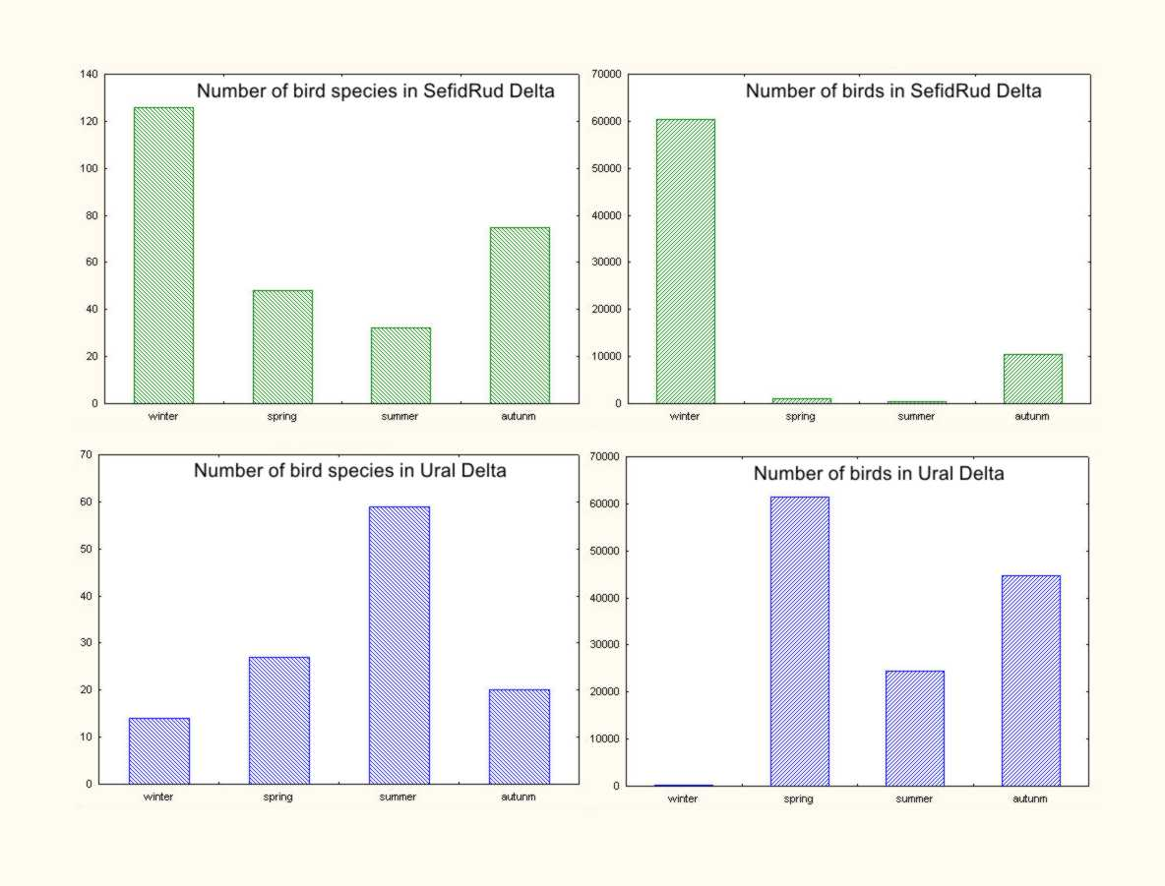
All-the-year-round monitoring of sensitive sites starts in winter 2006 and includes all seasons (winter-spring-summer-autumn). During the monitoring hundreds of species are identified and thousands of birds counted. Maximum attention is paid to the rare species of amphibians, reptilians, birds, and mammals. Seasonal dynamic of species composition and abundance of main species is analyzed for each sensitive site and for the region as a whole. Presence of many rare species is confirmed. Only in Iran more than half a million of birds are counted and 220 bird species are identified. Specimens of 37 rare and endangered species were found on Iranian site during winter time including such rare birds as Lesser Red-breasted Goose (Branta ruficollis) and Siberian crane (Grus leucogeranus). Similar figures were obtain for other countries: Azerbaijan – 300,000 specimens of birds, 216 species, 36 rare species; Turkmenistan – 380,000 specimens, 113 species, 15 rare species; Kazakhstan – 310 specimens, 122 species, 25 rare species; Russia – 220,000 specimens, 129 species, 26 rare species.

Similar data are obtained for other groups of terrestrial vertebrates: amphibians; reptiles, and mammals. Of course there is not such huge amount of counted species, but it is also very important data on coastal biodiversity. In addition plants distribution along the coast in Kazakhstan, Russia, Turkmenistan and Iran are provided. Some data also are available on fish distribution but not for specific sites.

Table XX. Number of species identified during monitoring survey around 25 sensitive sites on the Caspian coast (listed in the Red Data Books and total number of species).
 | Amphibians | Reptilians | Birds | Mammals
Azerbaijan | 5/9 | 5/26 | 36/216 | 10/49
I.R. Iran | 1/6 | 3/12 | 37/222 | 5/18
Kazakhstan | 0/2 | 2/16 | 25/122 | 2/30
Russia | no data | no data | 26/129 | no data
Turkmenistan | 0/2 | 2/15 | 15/113 | 6/20
Total | 5/10 | 6/43 | 53/320 | 16/76

4.3.1.2 Mnemiopsis leidyi monitoring

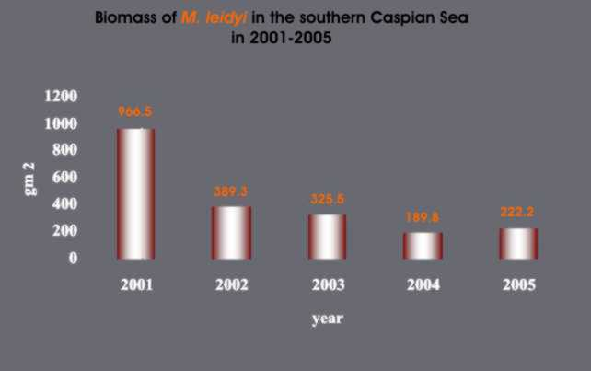
The first unclear report of presence Mnemiopsis leidyi in the Caspian Sea appeared in 1995. Unfortunately it was not identified and mentioned as a jelly-fish with out any description. So, it is not known was it really Mnemiopsis or any other jelly fish. The first scientific report on Mnemiopsis leydiy occurrence dated by 1999 and it was found and later identified by astrakhan’s scientists in the shallow water around Turkmenistan coastline. Later in 2000, Mnemiopsis leidyi was observed in huge amount all over South Caspian Sea. From that time the regular monitoring program started, which showed the bloom of this invasive species in the Caspian Sea and investigated it seasonal and spatial distribution in the Sea. Number and biomass of Mnemiopsis leidyi explosively increased in 2000-2002. In 2003-2006 it decreases a little and become more stable (A. Roohi, A.E. Kideys, G. Finenko, 2005. Impacts of Invasive Ctenophore Mnemiopsis leidyi on the Fisheries of the Black and Caspian Seas). The process of Mnemiopsis leidyi abundance stabilization is not finished so far, and in some specific sited it appears in huge amount even in the summer 2005.
It become evident, that Mnemiopsis leidyi is rather rare in the North Caspian due to it cold (in winter time) and less saline waters. It appears there only in summer time coming with water currents from the South. On the contrary South Caspian is the most favorite for it survive and reproduction. The maximum amounts of young animals were observed there as well as the total maximum amount and biomass. In a seasonal aspect ctenophore in the Caspian is a periodic animal. It amounts and biomass regularly increased from spring to summer with pick in the August. Later on with waters cooling amount of Mnemiopsis leidyi decreased. In winter and early spring time it almost disappears in the North Caspian Sea and presence in low amount in the Middle and South Caspian, starting to increase in May-June only. Maximum biomass of Mnemiopsis was observed in 2002 – 1700 specimens per m³ in the South Caspian Sea. Presence of huge amount of this zooplankton feeding species totally changes the structure of phyto- and zooplankton, and even benthic communities.
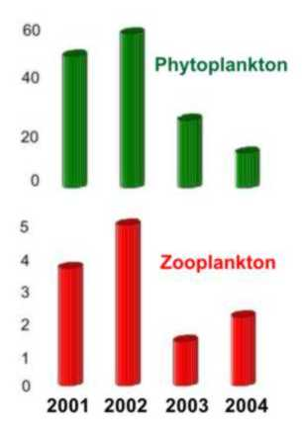
Diversity and biomass of zooplankton reduced in 2-3 times. In many locations instead of 10-17 species only one species (Acartia tonsa) was found in 2003. Similar changes were observed in the phytoplankton community – reduction of diversity and biomass in the period 2000-2003. Reduction in phytoplankton community was observed around the Southern coast and is difficult to explain. On the contrary, biomass and diversity of benthic community increased twice at the same period. In the period 2000-2003 rapid decline of tulka stock and fishery occurred (The present state of the Russian fishery of the Caspian kilka and biological characteristics of commercial catches. Kosturin et al, 2005; Official report from IFRO (Shilat official); AzNirkh data (Official report Azerbaijan SAPIC). Till now is not clear enough is decline of kilka due to over-fishing was a trigger to Mnemiopsis leidyi bloom or vise versa.

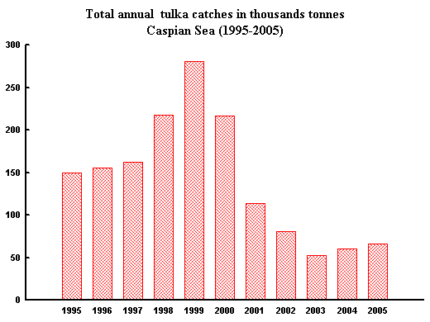
After four years bloom amount and biomass of Mnemiopsis leidyi starts to decline and now it is on a lower level, but it is still high. With decreasing of Mnemiopsis leidyi amount changing in zoo- and phytoplankton continued. Both communities become richer in species composition. Smaller forms appear in phytoplankton. This indicates positive tendency because these form are more valuable as a food resource for zooplankton. Diversity and amount of zooplankton also starts to increase. Several species appears in sufficient number, which has not been observed for several years. That is true first of all for Cladocerans in the shallow water near to the shore. On the other hand in the open sea (deep waters of the South-West Caspian) Acartia tonsa is the only dominant in zooplankton in the last few years composed 99%-100% of the total zooplankton biomass (Mnemiopsis leidyi is not count). Fishing of kilka also slowly increases in Iranian waters in 2004-2006. Invasion of Mnemioipsis leidyi disrupts the whole Caspian ecosystem and it has been near to collapse in a very simple, productive food chain, but useless for humans: Rhizosolenia calcar-avis – Acartia tonsa – Mnemiopsis leidyi. Now Caspian Sea is moving to a new equilibrium with presence of Mnemiopsis leidyi as it part along with many other zooplankton organisms and many other planktivorous species – kilkas, mullets and other.

Mnemiopsis leidyi (A.Agassiz)

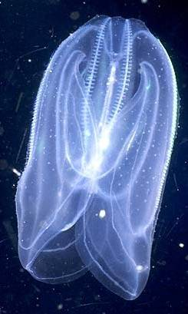
Ctenophora, polymorphic species; a self-fertilizing hermaphrodite; a generalist carnivorous feeder with main food: zooplankton, fish eggs and larvae; occurs over a broad range of salinity and temperature conditions.
The species is native to the West Atlantic coast with maximum abundance in it tropical part.
In the 1980s, the introduction occurs into the Black Sea that radically affected the whole ecosystem (Vinogradov 1989; Kideys 1994). This species had a negative impact on the most dominant fish of the Black Sea, the anchovy Engralius encrasicolus due to feeding competition on zooplankton as well as consumption of anchovy eggs and larvae. Meantime possibility of its introduction into other neighboring sensitive ecosystems, notably the Caspian Sea, has been mentioned (Dumont 1995; GESAMP 1997). As expected, this ctenophore was reported from the Caspian Sea by November 1999 (Esmaeili et al. 2000, Ivanov et al. 2000). Ivanov et al. (2000) suggested that ctenophore were transported with ballast water taken aboard in the Black Sea or the Sea of Azov and released after ballast-loaded ships passed through the Volga Don Canal and the shallow freshwater North Caspian Sea, into the saltier Central or South Caspian.
Invasion of the Caspian Sea by the comb-jelly Mnemiopsis leidyi since late 1990s has become one of the main environmental issue of this unique ecosystem. The case of Mnemiopsis leidyi in the Caspian Sea is among the largest invasion impacts ever occurred in a marine ecosystem all over the world.

4.3.1.3. Seals in the Caspian Sea

The seal is the only marine mammal in the Caspian Sea, feeding on tulka and other small fish, and preyed upon by land animals. It is endemic species for the Caspian Sea and is vulnerable on that point of view. During it life history Caspian seal migrates from the frozen North Caspian in winter to the South Caspian in the summer timer and back to the North to born pups on the ice. During these migration it can be found everywhere in the sea.
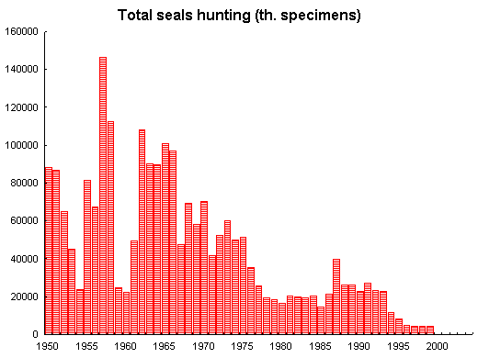
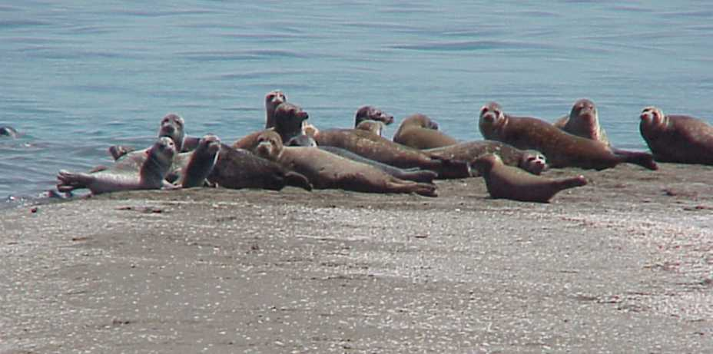
It is unclear how many seals remain in the Caspian Sea. From a population estimated at more than 1 million in the early 20th century, at present population estimates vary from about 110,000 to 350,000. For much of the 19th and 20th century, hunting was carried out (including pups) in the frozen North Caspian area. In the early 20th century, nearly 100,000 seals were taken each year by the hunt; later a quota was set at 40,000 seals per year, later 20,000 pups, and now is as low as few thousands. For the past decade, no organized hunting has taken place in the North Caspian, not for lack of a quota, but rather for lack of market for the seal products. In the years 2006-2007 due to decline in fishing resources seals’ hunting starts to become more active, especially in the North.
Listed on the IUCN Red List of Threatened Animals as vulnerable, the seal has been the victim of recent mass mortalities that have reduced the population even further. In 2000, a mass mortality caused some tens of thousands of deaths throughout the Caspian (Azerbaijan, Kazakhstan, Russia, and Turkmenistan). The 2000 mortality was particularly notable for the role played by canine distemper virus (CDV). Nearly all the seals examined in 2000 tested positive for this morbilivirus. Seals mortality repeated in 2006-2007 on the lower scale. About a thousand of dead seals were found around Aktau-Buzachi peninsula (Kazakhstan). All dead seals examined in 2007 are positive to CDV (Canin Distemper Virus) (Kazakhstan Institute of Microbiology Report, 2007). Earlier studies in other area of the world have shown that pollution may cause females to become barren as well as suppress their immunity system (De Swart RL, Ross PS, Vos JG, Osterhaus ADME. Impaired immunity in harbour seals (Phoca vitulina) exposed to bioaccumulated environmental contaminants: review of a long-term feeding study. Environmental Health Perspectives 104 (Suppl.4): 823-828 (1996). Up to 50%-70% of females are thought to be barren in the Caspian Sea. Ration of barren females changes in years and is still rather high. Also there is no estimation what is the natural rate of barren females for Caspian Seals.
Figure 3.2.1

Besides pollution and hunting, other stressors act on the Caspian seal population. A major food source for the seals is the tulka, one of the small and abundant fish of the Caspian. For the past decades kilka stocks are reduced dramatically due to several reasons: mass mortality in 2001, expanded fishing in the 1990-2000, invasion of the ctenophore Mnemiopsis leydyi. Caspian seal is almost 100% ichthyophage preferring fishes of small and middle size. The better data are available only for seal feeding in the North Caspian. Conclusions on its feeding in the Middle and South Caspian are more based on the calculations of food availability, expert estimations and extrapolations. Tulka always are an important part of the seal feeding – up to 30%-70% of the total food. In the North Caspian with more or less stable stock of tulka there are not many changes in the seals feeding in the last years. There are some seasonal changes in the seal food, which are in good correlation with availability of different prey species. Consumption of roach is regularly increased from spring to autumn, with maximum up to 50% in August-September. In the Middle and South Caspian the decreasing of tulka consumption in observed in the last years. Tulka is substituted by the sand-smelt (Atherina boyeri), and gobies (mainly Neogobius sp.). (Khuraskin et al 2001, 2003, 2004, 2005, 2006) The seal as an active predator prefers to prey the most available objects. From this point of view seal easily shifts from one fish species to another. Generally it is possible to estimate very broadly that each seal consumes up to 700-1000 kg of fish annually, and the part of tulka could be up to 100-150 thousands tons per year. This amount is comparable with the total tulka land off (all three species) and in the last time it even overcomes the human fishing. Obviously seal is more successful fisher comparing to the present fishery industry in the Caspian Sea. Consumption of tulka by the seals (and other predators) need to be accounted during calculation of the tulka TACs Total Allowable Catch).
Disturbance on the ice during pupping season and pups-mother separation become another threat to the seal population recognizing in the last years. In 2006 a study was carried out (with support from Agip KCO) to determine the response of breeding seals to the passage of an icebreaker. Behavior was recorded of 270 mother-pup pairs, 117 lone pups (without mothers visible from the ship) and 99 single adults as the ship progressed through the ice. Most of the pups (91% of pups recorded) were bearing the white, lanugo coat, 5% were moulting and 4% were fully moulted. There were more very small pups seen without their mother than statistically expected. Most of these small pups were seen along the edge of the shipping channel. Mother-pup pairs closer than 100m from the ship’s channel almost always moved away from the ship as it passed. Almost all pups followed their mothers as they moved away from the ship. Most mothers attempted to ensure that their pup was following by pausing or looking back at it. The maximum separation between mother and pup moving away from the side of the ship averaged less than 2m, but the average distance was 8m for pairs moving away from the channel edge. 10% of mothers fleeing from the channel edge failed to pause for their pups or look back at them, and the separation between these mothers and pups exceeded 20m. More than 40% of lone pups moving away from the channel edge tried to follow another seal, most often another lone pup.It was concluded that icebreaker passage through the seal pupping grounds has a measurable negative impact on seal welfare and may compromise the survival of some pups. A new pattern may be establishing where seals use the shipping channels to penetrate the ice field and establish breeding habitat on channel edges. A potential mitigation measure is to switch icebreaker routes after seals have established breeding territories, since after this critical period seals are not likely to move to new areas. Icebreakers should not traverse high density seal pupping habitat and should not pass within 100m of a mother-pup pair. Selecting a track to avoid breeding seals would require study of the establishing colonies in late January. 
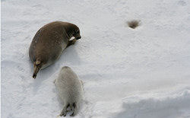
Mother pauses and turns round to look at pup
(photo by CISS team)
A special study commissioned by AGIP is aimed to review the pup production and density on winter ice fields in the northern Caspian. An aerial survey of Caspian seals on the winter ice-field was carried out in February 2005 and 2006 in order to assess the annual pup production and the size of the breeding population of the species. 11% of the icefield in Kazakh territory was surveyed in each year. The total number of pups counted was 2,140 in 2005 and 1,860 in 2006. The total Caspian seal population size is 110-115 thousands individuals, estimated from a ‘hind-casting’ model.
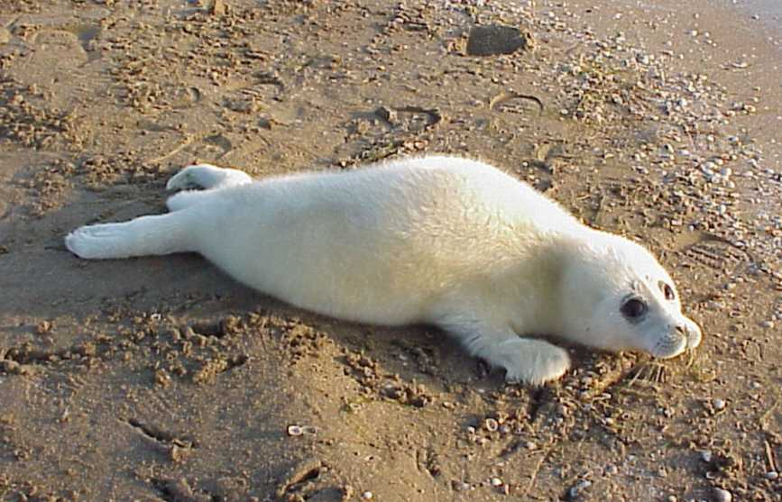Photo by Pavel Erokhin
In 2005, and to a lesser extent 2006, much of the seal ice habitat was occupied by seals at relatively low mean densities (up to 3 adults or pups per km²). In 2005 there were considerable areas of moderate adult and pup mean seal densities (3–6 adult or pups per km²) sometimes surrounding a relatively few areas of seal ‘hot spots’ of up to a mean density of 22 adults or 12 pups per km². However, in 2006 the majority of seals were crowded into small areas of more dense hot spots. In both years the hot spots were concentrated in the South-West of the ice area.
The total number of eagles (as potential predator) counted was 243 in both years, giving an estimate for the overall number of eagles on the ice of 2,209. Most of the eagles were found in groups of up to 15 birds at, or in the vicinity of, pools of blood. The eagle distribution in 2006 appeared to be more concentrated in fewer areas, and more correlated with pupping hot spots, than in Two wolves were counted in 2005 and none in 2006.
These studies provided key information for the Caspian Seal Conservation Action Plan which describes main activities need for seal conservation. All Caspian countries have adopted the CSCAP. On April 10, 2007 Dr. Makhtumkuli Akmuradov, in the capacity of SCM Chairperson, approved the CSCAP as ‘guidelines for the voluntary adherence of the countries’. CSCAP is addressed to the unsustainable use of bioresources and threats to biodiversity, which are prioritized as major environmental concerned areas in the Strategic Action Plan for the Caspian Sea. It is in correspondence with EQO II “Conservation of Biodiversity” particularly with Target 1 “Increased regional collaboration to achieve maximum regional benefits for biodiversity” and Target 2 “Ensure all key species are maintained or restored to viable levels”. In the Updated SAP seal conservation becomes a separate Target 4 among other targets of EQO 1 “Conservation and sustainable use of bioresources”.

4.3.3 Linkages with other transboundary problems

The issue of threats to biodiversity is very closely linked to the other transboundary problems in the Caspian region. This includes decline in environmental quality from pollution impacting the health of the ecosystems and therefore impacting biodiversity; decline in biodiversity having a negative impact on bioresources; excessive coastal flora impacting coastal habitat and infrastructure; and, oil and gas industry activities negatively impacting ecological conditions.
The decline in environmental quality can cause problems for wildlife and the biodiversity by creating additional stresses on to the health of specific populations within the Caspian. During the previous TDA the seal mortality events were tied to the increased phenols concentration in the waters, and additional studies has shown that there are also specific hotspots which may impact the health of localized biodiversity, such as near industrial centers along the Caspian coasts (need a reference from pollution section). Though there are other anthropogenic causes for threats to biodiversity, the decline in environmental quality and resulting decline in ecosystemic health with be reflected within the Caspian biodiversity as well. At this point it is useful to mention that zooplankton crustacean is the most sensitive and vulnerable group for presence of any type of pollutants. That is how even small increase of pollutants not dangerous for seals of fishes itself could disrupt the food chain and has a long-term indirect impact to all marine biota.
The decline in biodiversity is very closely linked to the decline in bioresources, as food chains are potentially disrupted with feeding patterns altered due to these shifts. Because of the unique biodiversity of the region, and high number of endemic species, a disturbance in food chains may impact species that are of high ecologic and economic value such as sturgeon. With introduction of Mnemiopsis leidyi as well as other species the naturally occurring food web undergoes potentially significant disruptions, which is in turn impact the human conditions within the region, especially in a high value industry affiliated with the harvesting of Caspian bioresources.
Threats to biodiversity, including invastive species of flora and fauna can have significant impacts on coastal habitat and infrastructure. The clogging of harbors from invasive flora species and challenges to habitats could be significant. Wetland habitats are especially vulnerable to invasive species, and again the prevalent food chains could be disrupted.
The most visible threat to biodiversity is the oil and gas industry impacts. Though this is not necessarily the most prevalent or direct threat, the perception is that this threat is most pervasive due to the high profile accidents within the petroleum industry. The threats that do exist to biodiversity are related to the importation of invaders through ballast waters, threats to seal breading grounds on ice flows within the northern Caspian, and general disturbance of coastal and marine ecosystems due to activation of human presence in the region. The threat of accidental discharges is also significant, and many oil companies are taking steps to guard against this, as much as possible.

4.3.4 Climate change impacts
(My suggestion is to exclude this chapter as the Climate change is a Natural phenomena and it is rather difficult to say anything about it impact on biodiversity. Scientifically it is very difficult to predict anything)

Climate change impacts on biodiversity in the Caspian Sea region are difficult to forecast, as clear models do not currently exist.
If the conditions become hotter and drier in the region due to a decline in rainfall in the basins of tributaries, it can be expected that this will impact the Caspian by diminishing wetlands, reducing flows into the Caspian and increasing evaporation. This in tern would result in concentrated habitats and increased salinity within the seas. The result could be shifts in the food chain composition.
In the event that conditions become wetter and cooler, there is a chance that increased pollutants from coastal sea level rise, combined with larger influxes of pollutants from flooding in tributaries may also impact regional biodiversity.
Shifts in freezing patterns in the northern Caspian ice could have consequences for seal populations as pupping patterns are disrupted.

4.3.4 Knowledge gaps

The foregoing discussion clearly indicates that threats are not limited to direct human activity, and that ecological interactions initiated by species introductions may still be in a state of change. One key area to focus on is a study of primary and secondary production and diversity in the phytoplankton-zooplankton-benthos communities as a fundamental basis for the health of the entire marine system.
Absence of a clear quantitative description of ecological and biodiversity status (for taxonomic and ecological groups and for the region), which makes it impossible to identify either causes or solutions. What must be avoided at all costs is mis-identifying the problem – this must be done on the basis of reliable and quantitative data, not on the basis of opinion or belief. Resources must be directed at the real problems – the worst outcome would be to allocate precious resources to the wrong problems, since this would guarantee that no effective solutions would be implemented.
The main gaps are the nature of CDV in Caspian seal population; quantitative data on pollution impact on immunity suppression, and on female fertility for Caspian population.
There is less known about distribution and development of marine plants, especial rare ones. Existed materials are fragmental and perform on different methodology.
Absence of Regional Caspian Catalogue of invasive species and it impacts.
Absence of Regional agreed Red list of species. Species statuses in many cases are different for five countries as it were created for the whole area in each country without special concern to the Caspian Region.

4.3.5 Recommendations

Need to conduct Caspian Biodiversity census to establish empirically based cataloging of regional biodiversity. Based on existing knowledge continue biodiversity monitoring (with permanent consultation of experts within the region) to estimate trends in changing of regional biodiversity and in changing in dominants.
Identification of Biodiversity hot spots – for focused attentions, especially for marine habitats.
Creation of Caspian Red Book of endangered and threatened species.
Follow up studies on presence and natural reserve of CDV, and other pollutants in organism of seal.
Provide enforcement groups such as fisheries enforcement/border guards and nature preserve staff with support through information exchange forums, strategy workshops, and training by the authorities from other regions who face similar challenges.
Develop informational materials on the economic importance of protecting regional biodiversity for distribution through Interministerial Committees to related ministries.

